**Task: Login System using handlebar**

**Code**

**Error.hbs file**

<h1>{{error.status}} {{message}}</h1>

<pre>{{error.stack}}</pre>

**Index.hbs file**

<div class="container">

<div class="row">

<div class="col-xs-12 col-sm-12 col-md-12 col-lg-12">

<form action="/" method="post" role="form" enctype="application/x-www-form-urlencoded">

<legend>Enter Registration Information below</legend>

<div class="form-group">

<label for="first_name">First Name</label>

<input type="text" class="form-control" name="first_name" id="first_name" placeholder="First Name">

</div>

<div class="form-group">

<label for="last_name">Last Name</label>

<input type="text" class="form-control" name="last_name" id="first_name" placeholder="Last Name">

</div>

<div class="form-group">

<label for="email">Email Address</label>

<input type="text" class="form-control" name="email" id="email" placeholder="Email Address">

</div>

<div class="form-group">

<label for="pw">Password</label>

<input type="password" class="form-control" name="pw" id="pw">

</div>

<div class="form-group">

<label for="pw_confirm">Confirm Password</label>

<input type="password" class="form-control" name="pw_confirm" id="pw_confirm">

</div>

<button type="submit" class="btn btn-success">Submit</button>

<button type="cancel" class="btn btn-secondery ">Cancel</button>

</form>

</div>

</div>

</div>

**Layout.hbs file**

<!DOCTYPE html>

<html>

<head>

<title>{{title}}</title>

<script

src="https://code.jquery.com/jquery-3.2.1.js"

integrity="sha256-DZAnKJ/6XZ9si04Hgrsxu/8s717jcIzLy3oi35EouyE="

crossorigin="anonymous"></script>

<!-- Latest compiled and minified CSS & JS -->

<link rel="stylesheet" media="screen"

href="https://maxcdn.bootstrapcdn.com/bootstrap/3.3.7/css/bootstrap.min.css">

<script src="https://maxcdn.bootstrapcdn.com/bootstrap/3.3.7/js/bootstrap.min.js"></script>

<link rel='stylesheet' href='/stylesheets/style.css' />

</head>

<body>

{{{body}}}

</body>

</html>

**Welcome.hbs file**

<div style="background-color:rgb(138, 228, 255);" class="jumbotron">

<div class="container">

<h1>Hello {{first_name}} {{last_name}}!</h1>

<p>You are registered with an email address of {{email}}</p>

<p>Well done!</p>

</div>

</div>

**Index.js route file:**

var express = require('express');

var router = express.Router();

/* GET home page. */

router.get('/', function(req, res, next) {

res.render('index', { title: 'Node Tutorial' });

});

router.post('/', function(req, res){

var body = req.body;

var res_body = {

first_name: body.first_name,

last_name: body.last_name,

email: body.email

};

res.render('welcome', res_body);

});

module.exports = router;

**App.js file:**

var express = require('express');

var path = require('path');

var favicon = require('serve-favicon');

var logger = require('morgan');

var cookieParser = require('cookie-parser');

var bodyParser = require('body-parser');

var index = require('./routes/index');

var app = express();

// view engine setup

app.set('views', path.join(__dirname, 'views'));

app.set('view engine', 'hbs');

// uncomment after placing your favicon in /public

//app.use(favicon(path.join(__dirname, 'public', 'favicon.ico')));

app.use(logger('dev'));

app.use(bodyParser.json());

app.use(bodyParser.urlencoded({ extended: false }));

app.use(cookieParser());

app.use(express.static(path.join(__dirname, 'public')));

app.use('/', index);

// catch 404 and forward to error handler

app.use(function(req, res, next) {

var err = new Error('Not Found');

err.status = 404;

next(err);

});

// error handler

app.use(function(err, req, res, next) {

// set locals, only providing error in development

res.locals.message = err.message;

res.locals.error = req.app.get('env') === 'development' ? err : {};

// render the error page

res.status(err.status || 500);

res.render('error');

});

module.exports = app;

**bin/www file:**

var express = require('express');

var path = require('path');

var favicon = require('serve-favicon');

var logger = require('morgan');

var cookieParser = require('cookie-parser');

var bodyParser = require('body-parser');

var index = require('./routes/index');

var app = express();

// view engine setup

app.set('views', path.join(__dirname, 'views'));

app.set('view engine', 'hbs');

// uncomment after placing your favicon in /public

//app.use(favicon(path.join(__dirname, 'public', 'favicon.ico')));

app.use(logger('dev'));

app.use(bodyParser.json());

app.use(bodyParser.urlencoded({ extended: false }));

app.use(cookieParser());

app.use(express.static(path.join(__dirname, 'public')));

app.use('/', index);

// catch 404 and forward to error handler

app.use(function(req, res, next) {

var err = new Error('Not Found');

err.status = 404;

next(err);

});

// error handler

app.use(function(err, req, res, next) {

// set locals, only providing error in development

res.locals.message = err.message;

res.locals.error = req.app.get('env') === 'development' ? err : {};

// render the error page

res.status(err.status || 500);

res.render('error');

});

module.exports = app;

**OUTPUT**

Home page

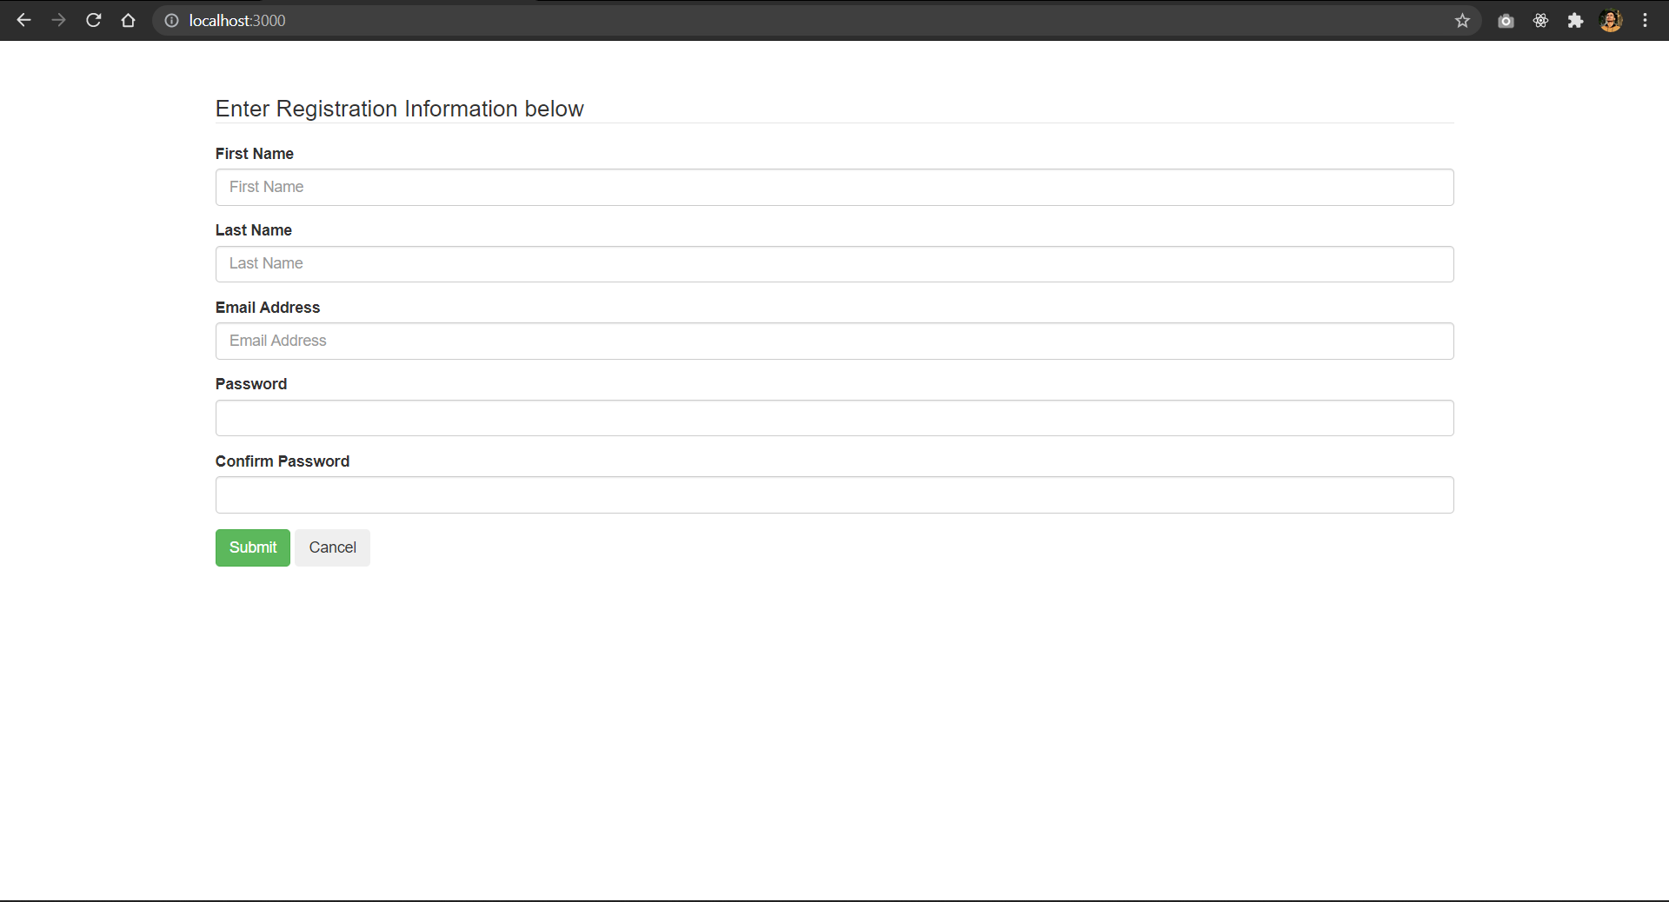

Welcome page after login:

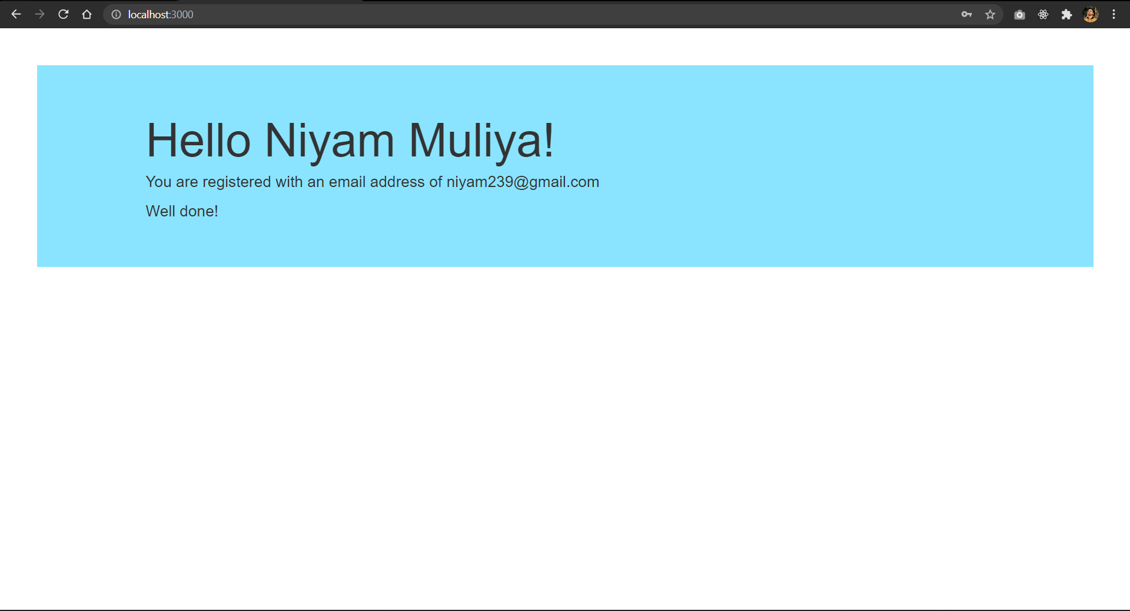

Error if given route is not defind:

